ADATTAMENTO DELLA LETTURA "What NOT to do on holiday" pag. 34

What NOT to do on holiday
Read the text and answer the questions.
1. What should you do before you pack?
.........................................
.........................................
.........................................
.........................................
2. Why isn't it necessary to take a lot of sports gear with you?
.........................................
.........................................
.........................................
3. Why is it a good idea to get a phrase book?
.........................................
.........................................
.........................................
.........................................
Luggage
You probably won't use half of the things that you pack, so think carefully about what you'll need. You won't need a torch when you're on a city break in a five-star hotel, but it might be useful if you're going to go camping in a field full of cows.
impacchettare
pausa
campo mucche
Sports gear
Are you going to do any sport while you're away? There's loads of stuff that you can hire when you're on holiday, like tennis rackets, a snorkel and so on. So before you go on a skiing trip, you don't need to run out and buy lots of winter sports equipment.
quantità di roba
noleggiare
boccaglio
Chat
Some people like chatting to people they meet and others don't. So don't tell everyone your life story. Remember - the person next to you on your journey didn't sit there to become your friend and can't escape. On the other hand, it's a good idea to learn a few phrases in the local language when you travel abroad. People will appreciate it.
viaggio

Health
4. How can you avoid getting a red face?
.........................................
.........................................
.........................................
.........................................
5. What kind of souvenirs should you avoid?
.........................................
.........................................
.........................................

6. What should you remember when you're listening to your MP3 player?
.........................................
.........................................
7. When's the best time to play your guitar?
.........................................
.........................................
.........................................

The weather forecast says it's going to be hot on your holiday. Think of your health as well as your image. It's nice to have a tan, but don't forget your suncream. Your holiday romance won't start well if you've got a face like a tomato.
abbronzatura
Souvenirs
Memories of your trip are precious, but will your really wear that Hawaiian shirt after your holiday? And where will you put that giant fluffy penguin when you get home? Maybe it's kinder to leave it with its friends in the souvenir shop.
Music
Loud music will probably annoy your travel companions. It's great to have music with you, but for other people, your MP3 player can sound like you've got a gang of mad flies in your ears. So watch the volume or save your music for moments of solitude. And remember that a guitar is OK when you're with friends, but strangers might not agree that you're going to be Number 1 one day.
stranieri
un mucchio di mosche impazzite

Esercizio 1 pag. 36
Check the meaning of the verbs. Then complete the sentences.
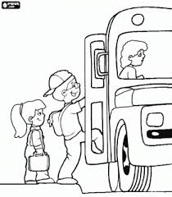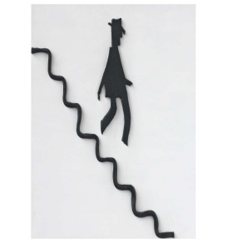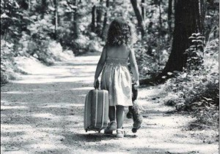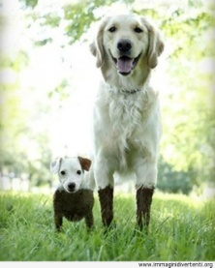
get on get off set off come back come across
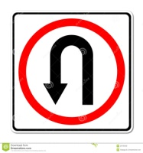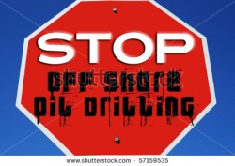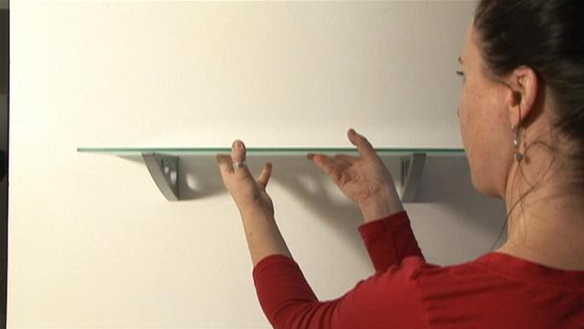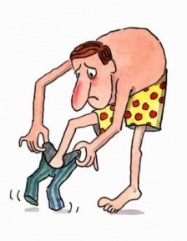
turn back stop off put up put on take off

1. You must __________________ your helmet before you ride that motorbike. It's the law.
2. We _____________________ an English friend in our house last summer.
3. I miss Sally. I hope she'll ____________________ soon.
4. We'll _________________ in Singapore for two days on our way to Australia.
5. This is your train. _________________ before it leaves!
6. The boat will __________________ if the weather's really bad.
7. Our flight's going to _____________________ from Heathrow.
8. Did you ____________________ any interesting restaurants in Barcelona?
9. __________________ your bike, please. This is a pedestrian zone.
10. They ________________ from London at the start of their journey.
